Line Segment
# Source: AI Source: Provided by: [Data Path: Persons Table -> ID Column: 1, Name_En Column: Motasem Essam] -> From: [ChatGPT] on [7/25/2026]
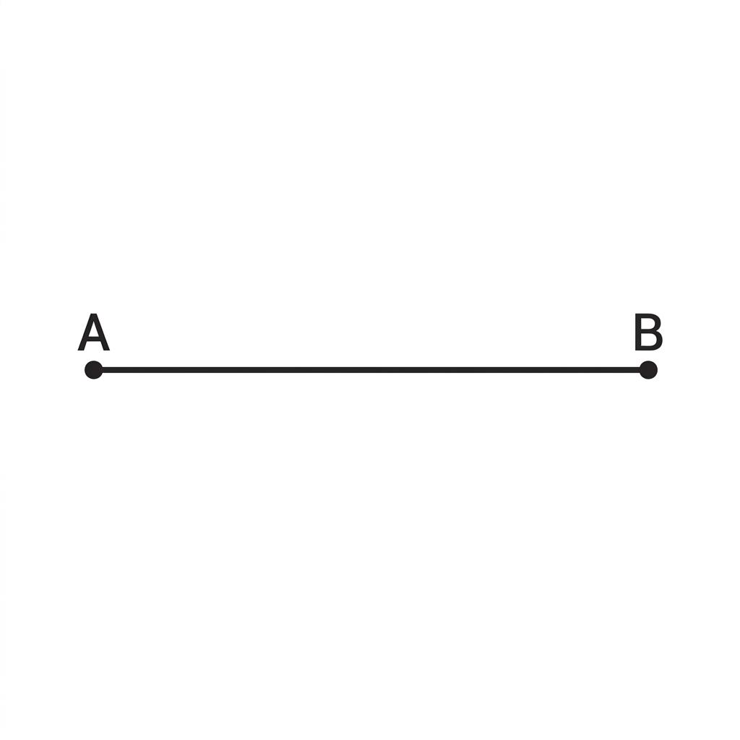
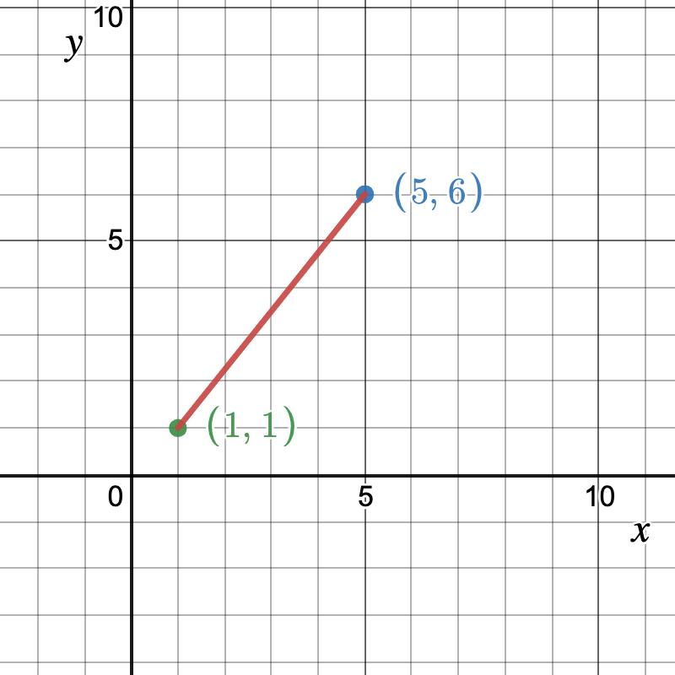
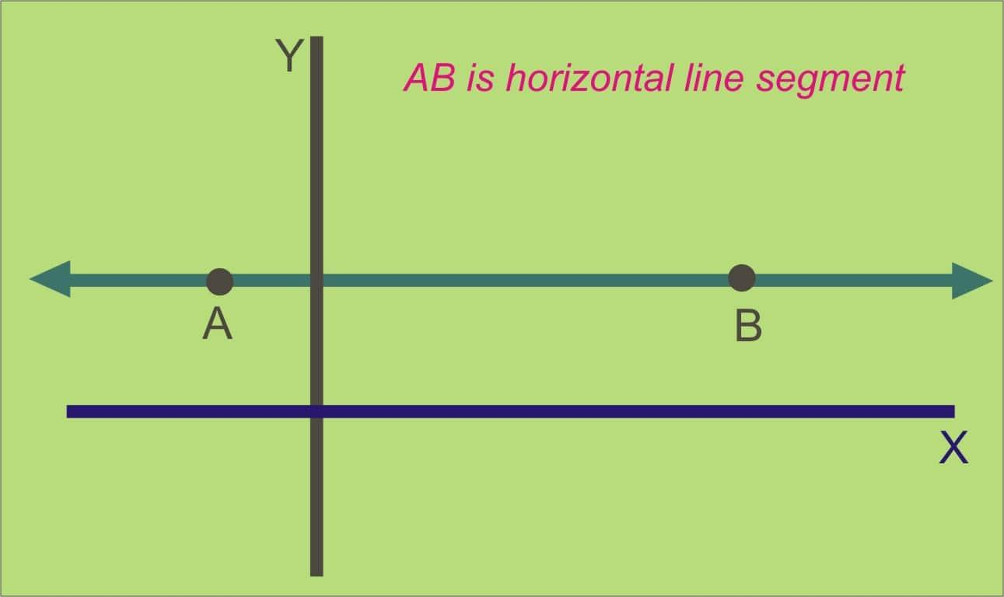
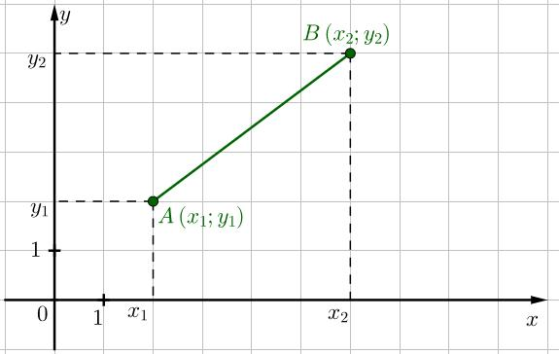
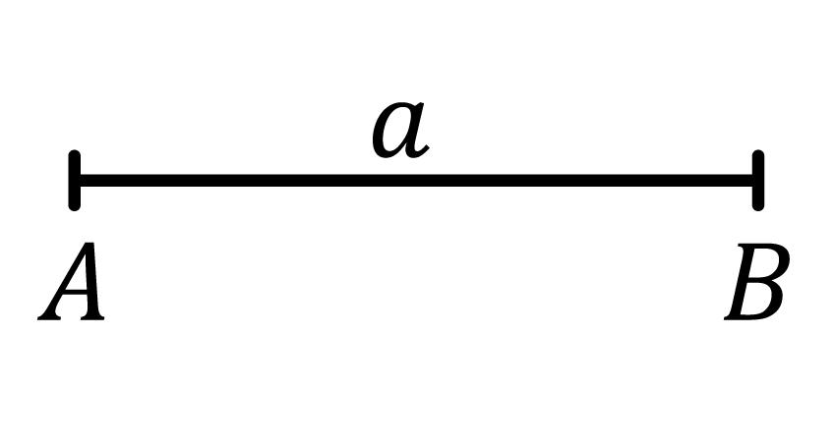
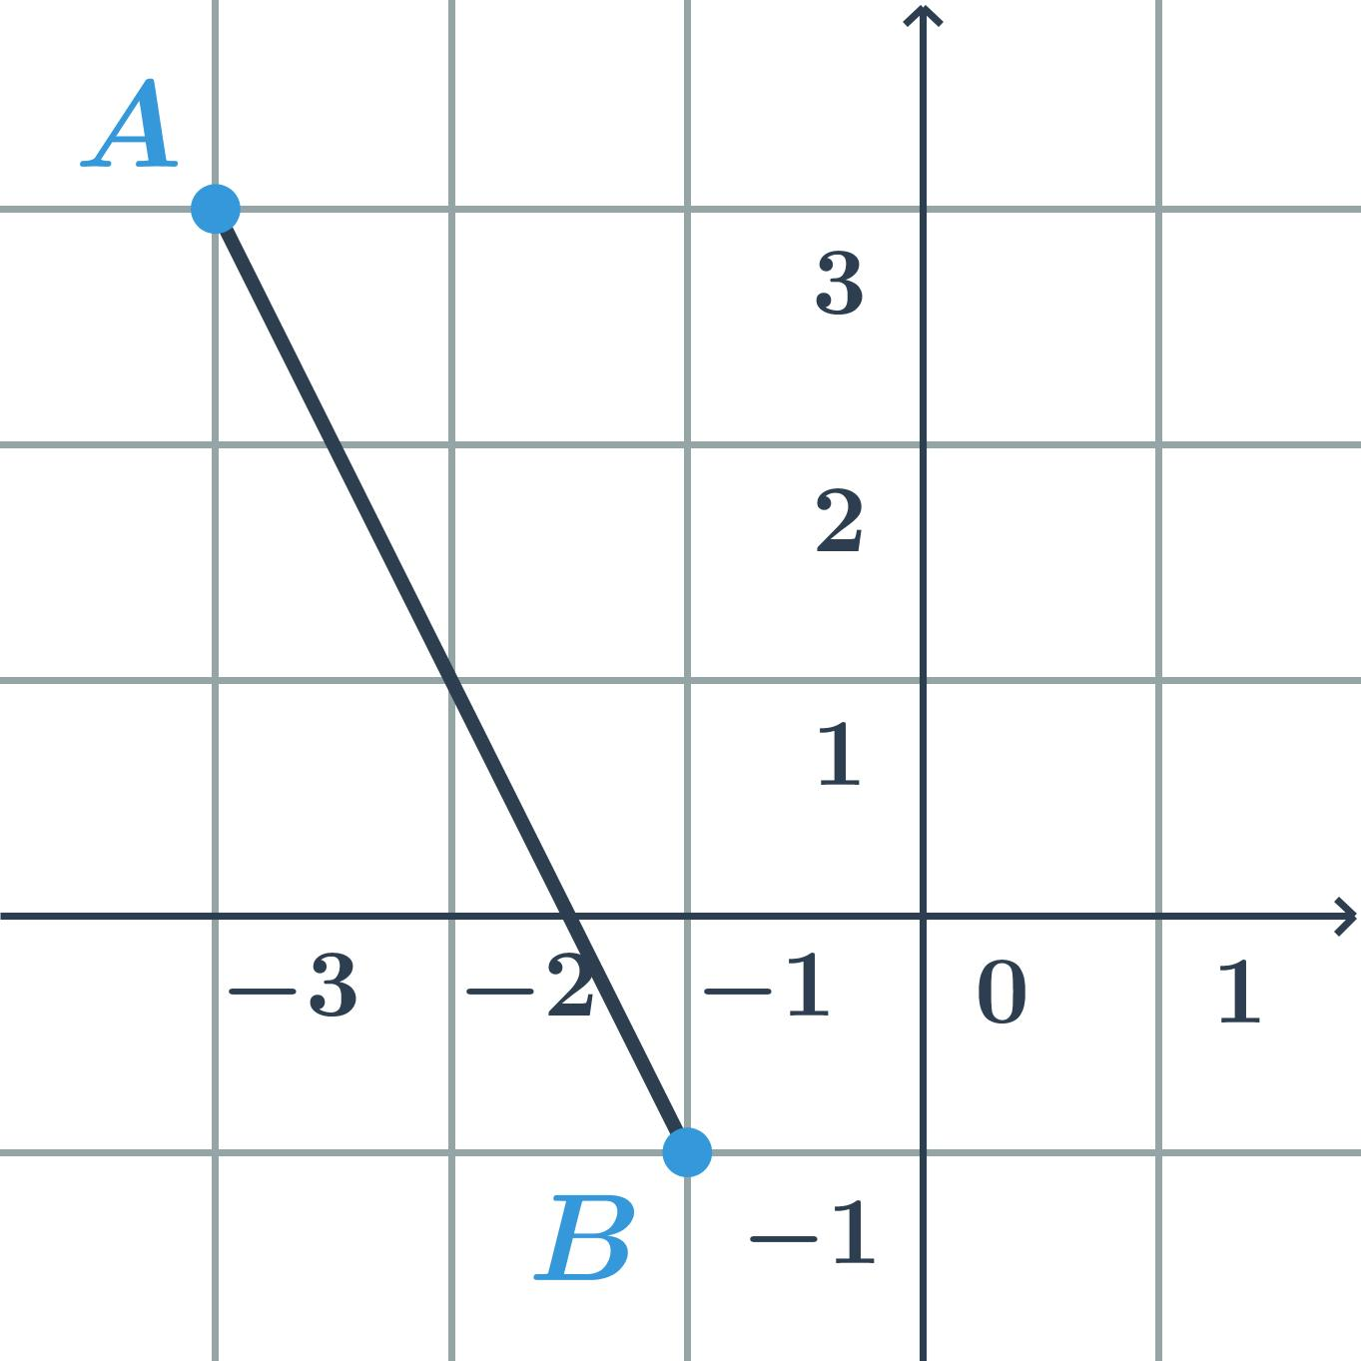

Definition
# Source: AI Source: Provided by: [Data Path: Persons Table -> ID Column: 1, Name_En Column: Motasem Essam] -> From: [ChatGPT] on [7/25/2026]
A Line Segment is a finite part of a line that is bounded by two endpoints. Unlike a line, which extends infinitely in both directions, a line segment has a fixed length and can be measured.
A line segment contains all the points between its two endpoints.

Characteristics
# Source: AI Source: Provided by: [Data Path: Persons Table -> ID Column: 1, Name_En Column: Motasem Essam] -> From: [ChatGPT] on [7/25/2026]
A line segment:
- Has two endpoints.
- Has a finite length.
- Is perfectly straight.
- Is one-dimensional.
- Can be measured.
- Does not extend beyond its endpoints.

Illustration
# Source: AI Source: Provided by: [Data Path: Persons Table -> ID Column: 1, Name_En Column: Motasem Essam] -> From: [ChatGPT] on [7/25/2026]
A •──────────────• B
The line segment starts at A and ends at B.

Mathematical Representation
# Source: AI Source: Provided by: [Data Path: Persons Table -> ID Column: 1, Name_En Column: Motasem Essam] -> From: [ChatGPT] on [7/25/2026]
A line segment joining points A and B is written as:
$$\overset{‾}{AB}$$
where:
- $A$= first endpoint
- $B$= second endpoint

Length of a Line Segment
# Source: AI Source: Provided by: [Data Path: Persons Table -> ID Column: 1, Name_En Column: Motasem Essam] -> From: [ChatGPT] on [7/25/2026]
For points
$$A\left(x_{1} , y_{1}\right)$$
and
$$B\left(x_{2} , y_{2}\right)$$
the length of the line segment is:
$$AB=\sqrt{{\left(x_{2}-x_{1}\right)}^{2}+{\left(y_{2}-y_{1}\right)}^{2}}$$
This is known as the distance formula.

Examples
# Source: AI Source: Provided by: [Data Path: Persons Table -> ID Column: 1, Name_En Column: Motasem Essam] -> From: [ChatGPT] on [7/25/2026]
Examples of line segments include:
- The side of a triangle.
- The edge of a rectangle.
- A ruler's edge.
- A bridge span.
- A road section between two intersections.

Types of Line Segments
# Source: AI Source: Provided by: [Data Path: Persons Table -> ID Column: 1, Name_En Column: Motasem Essam] -> From: [ChatGPT] on [7/25/2026]
Common classifications include:
- Horizontal Line Segment
- Vertical Line Segment
- Oblique (Diagonal) Line Segment
- Equal (Congruent) Line Segments
- Adjacent Line Segments
- Parallel Line Segments
- Perpendicular Line Segments

Properties
# Source: AI Source: Provided by: [Data Path: Persons Table -> ID Column: 1, Name_En Column: Motasem Essam] -> From: [ChatGPT] on [7/25/2026]
A line segment:
- Has exactly two endpoints.
- Has a definite measurable length.
- Is the shortest distance between its endpoints.
- Contains infinitely many points between the endpoints.
- Lies on a straight line.

Applications
# Source: AI Source: Provided by: [Data Path: Persons Table -> ID Column: 1, Name_En Column: Motasem Essam] -> From: [ChatGPT] on [7/25/2026]
Line segments are used in:
- Plane Geometry
- Coordinate Geometry
- Engineering
- Architecture
- Construction
- Surveying
- CAD (Computer-Aided Design)
- Computer Graphics
- Robotics
- GIS (Geographic Information Systems)

Advantages
# Source: AI Source: Provided by: [Data Path: Persons Table -> ID Column: 1, Name_En Column: Motasem Essam] -> From: [ChatGPT] on [7/25/2026]
Studying line segments helps to:
- Measure distances.
- Construct geometric figures.
- Analyze geometric relationships.
- Support engineering drawings.
- Perform coordinate geometry calculations.

Limitations
# Source: AI Source: Provided by: [Data Path: Persons Table -> ID Column: 1, Name_En Column: Motasem Essam] -> From: [ChatGPT] on [7/25/2026]
A line segment:
- Has finite length.
- Does not extend infinitely.
- Is limited by its two endpoints.

Comparison with Related Objects
# Source: AI Source: Provided by: [Data Path: Persons Table -> ID Column: 1, Name_En Column: Motasem Essam] -> From: [ChatGPT] on [7/25/2026]
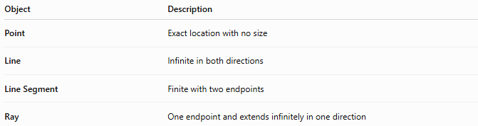
Object | Description
Point | Exact location with no size
Line | Infinite in both directions
Line Segment | Finite with two endpoints
Ray | One endpoint and extends infinitely in one direction

Key Points
# Source: AI Source: Provided by: [Data Path: Persons Table -> ID Column: 1, Name_En Column: Motasem Essam] -> From: [ChatGPT] on [7/25/2026]
- A Line Segment is a finite portion of a line.
- It has two endpoints.
- It has a measurable length.
- It is represented by:
$$\overset{‾}{AB}$$
- Its length can be calculated using the distance formula.
- Line segments are fundamental in geometry, engineering, construction, CAD, surveying, and computer graphics.

Conclusion
# Source: AI Source: Provided by: [Data Path: Persons Table -> ID Column: 1, Name_En Column: Motasem Essam] -> From: [ChatGPT] on [7/25/2026]
A Line Segment is a finite, straight geometric object bounded by two endpoints and represents the shortest distance between them. Unlike a line, it has a measurable length and does not extend indefinitely. Line segments form the sides of geometric figures and are fundamental in plane geometry, coordinate geometry, engineering, architecture, construction, surveying, CAD, robotics, GIS, and computer graphics, where precise distance measurement and geometric construction are essential.

